1. Configura bd:

Copiar .env.exemplo para .env (este possui a configuracao do banco)

1. Inicial Aplicacao

C:\estudos\teste-dev\api-message>php artisan serve

Starting Laravel development server: http://127.0.0.1:8000

1. Carrega caminho no postman para testes:

Carreega url: <http://127.0.0.1:8000>

**Headers:**

Configura Key: Content-Type

Valor: XMLHttpRequest

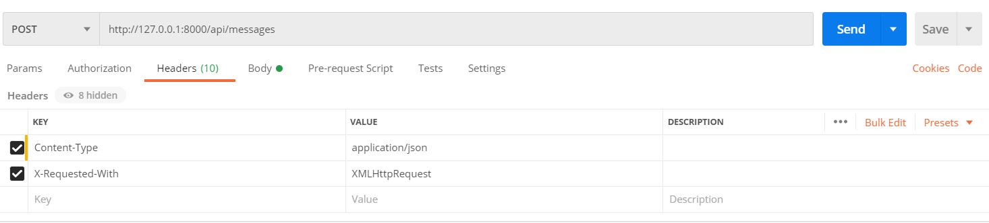

**Body:**

Configura Key: file_message

Valor: <arquivo no formato definido>

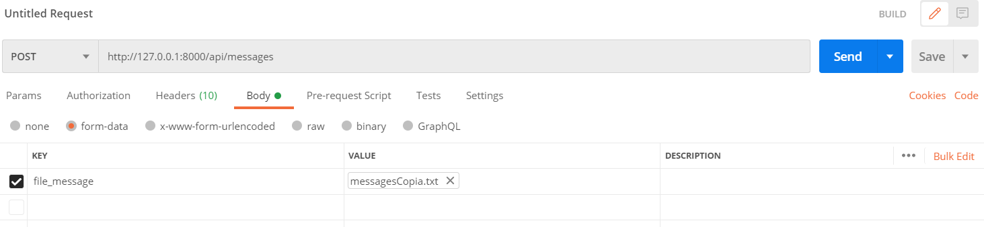

bff58d7b-8b4a-456a-b852-5a3e000c0e63;12;996958849;NEXTEL;21:24:03;sapien sapien non mi integer ac neque duis bibendum

b7e2af69-ce52-4812-adf1-395c8875ad30;46;950816645;CLARO;19:05:21;justo lacinia eget tincidunt eget

e7b87f43-9aa8-414b-9cec-f28e653ac25e;34;990171682;VIVO;18:35:20;dui luctus rutrum nulla tellus in sagittis dui

c04096fe-2878-4485-886b-4a68a259bac5;43;940513739;NEXTEL;14:54:16;nibh fusce lacus purus aliquet at feugiat

d81b2696-8b62-4b8b-af82-586ce0875ebc;21;983522711;TIM;16:42:48;sit amet eros suspendisse accumsan tortor quis turpis sed ante

**Após Processamento:**

Retorno com evidencias de regras e formato final na ultima linha:

